
Faculty of Computer Applications
MCA Sem-1 (AY-2026-27)
Lab Book
Sub Code: 05MC0108
(DBMS)
Enrollment No : | 92600584085
Full Name : | Hetvi chotara

Sub.Faculty Name: Dr. Jaypalsinh A. Gohil

Index
Unit : 1 Exercise No | Unit : 1 Definition
1 | Write a PL/SQL block that find  - Area of Circle  - Area of Rectangle  - Circumference of Circle
2 | Write a PL/SQL block to accept product name, qty and price from user and then calculate discount in Rs. based on the given (%).
3 | Write a PL/SQL block to calculate the total, percentage and grade of student based on his/her Rollno from RESULT table. (Create RESULT table with Rollno, Name, Sub1, Sub2, Sub3, Sub4, Sub5, Total, Per, Grade attributes with appropriate data type).
4 | Write a PL/SQL block which accepts measurement in feet and displays it in cm, inch and meter.
5 | Write a PL/SQL block to calculate the square and cube of the given number.
6 | Write a PL/SQL block which accepts measurement in feet and displays it in cm, inch and meter.
7 | Write a PL/SQL block which converts temperature from Celsius to Fahrenheit.
8 | Write a PL/SQL block to delete the record of employee for given EID.
9 | Write a PL/SQL block that calculates the simple interest based on given principal amount, rate of interest and number of years.
10 | Write a PL/SQL block to calculate the square and cube of the given number.
Unit : 2 Exercise No | Unit : 2 Definition
11
12
13

14
15
Unit : 3 Exercise No | Unit : 3 Definition
16
17
18
19
20
Unit : 5 Exercise No | Unit : 5 Definition
21
22
23

1. Write a PL/SQL block that find:
- Area of Circle
- Area of Rectangle
- Circumference of Circle

/* write a pL/Sql block the find area of circle*/

set serveroutput on
set feedback off
set verify off

declare
pi constant number(7,2):= 3.14;
radius number(5);
area number(9,2);

begin
radius:=&radius;
area:=pi*(radius*radius);
Dbms_output.put_line('the value of area is :'||area);

end;
/

set serveroutput off
set feedback on
set verify on

Output:
/* area_of_rectengle*/

set serveroutput on
set feedback off
set verify off

declare

length number(6,2):= 3.14;
width number(6,2);
area number(9,2);

Begin

length := &length;
width := &width;

area:= length*width;

Dbms_output.put_line('area of rectengle is: '||area);

end;
/

set serveroutput off
set feedback on
set verify on

Output:
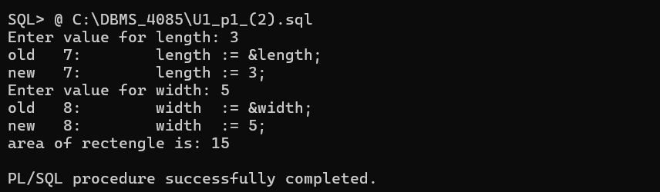

/* write a pL/Sql block the find Circumference of Circle */

set serveroutput on
set feedback off
set verify off

declare
c number:=&choice;
pi constant number(2,1):=3.14;
r number(4);
carea number(3,2);

l number(5);
w number(5);
rarea number(3,2);
cir number(2,1);

begin
c:=&choice;
r:= &r;
l:=&l;
w:=&w;
carea:= pi*power(2,1);

dbms_output.put_line('The Circumference of Circle:'||carea);
end;
/

set serveroutput off
set feedback on
set verify on

Output:
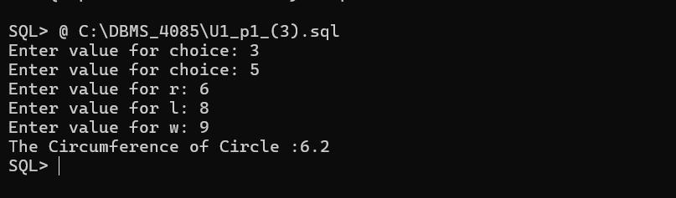

2. Write a PL/SQL block to accept product name, qty and price from user
and then calculate discount in Rs. based on the given (%)

/*Write a PL/SQL block to accept product name, qty and price from user
and then calculate discount in Rs. based on the given (%)*\

set serveroutput on
set verify off
set feedback off

Declare
pname varchar2(20);
qty number(5);
price number(7,2);
tp number(7,2);
discount number(5);
fp number(7,2);
begin
pname:= '&pn';
qty:= &qty;
price:= &price;
discount:= &discount;

tp:= qty*price;
fp:= (tp-(tp*discount/100));

Dbms_output.put_line('The product name is:- '||pname);
Dbms_output.put_line('total qty is:- '||qty);
Dbms_output.put_line('Total price is:- '||price);
Dbms_output.put_line('Total discount is:- '||discount);
Dbms_output.put_line('final price is:- '||fp);

end;
/

set serveroutput off
set verify on
set feedback on

Output:
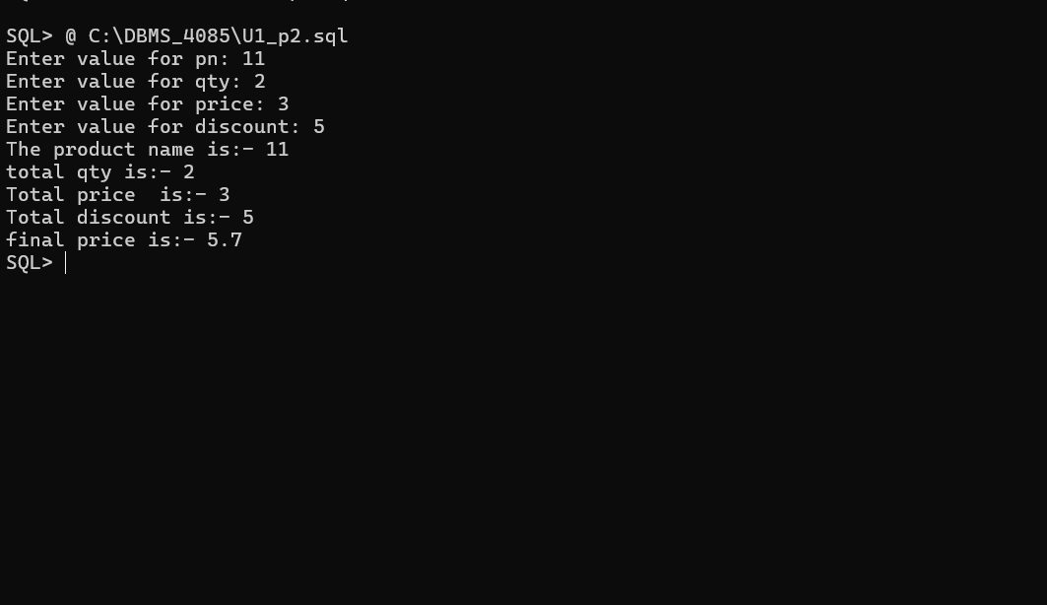

3.Write a PL/SQL block to calculate the total, percentage and grade of student based on his/her Rollno from RESULT table. (Create RESULT table with Rollno, Name, Sub1, Sub2, Sub3, Sub4, Sub5, Total, Per, Grade attributes with appropriate data type).

/*Write a PL/SQL block to calculate the total, percentage and grade of
student based on his/her Rollno from RESULT table. (Create RESULT
table with Rollno, Name, Sub1, Sub2, Sub3, Sub4, Sub5, Total, Per,
Grade attributes with appropriate data type). */

set serveroutput on
set verify off
set feedback off

declare
rollno number;
name varchar2(30);
class varchar2(10);
div char(1);
sub1 number;
sub2 number;
sub3 number;
sub4 number;
sub5 number;
total number;
per number(11,2);
grade varchar2(14);

begin
rollno := &rollno;
name := '&name';
class := '&class';
div := '&div';
sub1 := &sub1;

sub2 := &sub2;
sub3 := &sub3;
sub4 := &sub4;
sub5 := &sub5;

total := sub1+sub2+sub3+sub4+sub5;
per := total/5;

if per >= 70 then
grade := 'A';
elsif per >= 60 then
grade := 'B';
elsif per >= 50 then
grade := 'C';
elsif per >= 40 then
grade := 'E';
else
grade := 'failed';
end if;

dbms_output.put_line(' result');
dbms_output.put_line('rollno = '||rollno);
dbms_output.put_line('name = '||name);
dbms_output.put_line('class = '||class);
dbms_output.put_line('div = '||div);
dbms_output.put_line('sub1 = '||sub1);
dbms_output.put_line('sub2 = '||sub2);
dbms_output.put_line('sub3 = '||sub3);
dbms_output.put_line('sub4 = '||sub4);
dbms_output.put_line('sub5 = '||sub5);
dbms_output.put_line('total = '||total);
dbms_output.put_line('per = '||per);
dbms_output.put_line('grade = '||grade);

insert into result
(rollno,name,sub1,sub2,sub3,sub4,sub5,total,per,grade,class,div)
values
(rollno,name,sub1,sub2,sub3,sub4,sub5,total,per,grade,class,div);

end;
/

set serveroutput off
set verify on
set feedback on

Output:

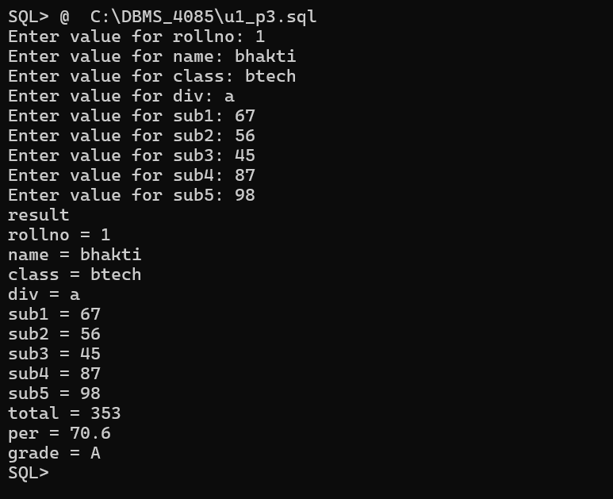

4. Write a program that prints value 1 to 100 numbers using FOR LOOP.

/* Write a program that prints value 1 to 100 numbers using FOR LOOP.*\

set serveroutput on
set feedback off
set verify off

Declare
n number;
I number;

Begin
n:=&n;
for I in 1..100
loop

Dbms_output.put_line(I);

End loop;
End;
/

set serveroutput off
set feedback on
set verify on

Output:
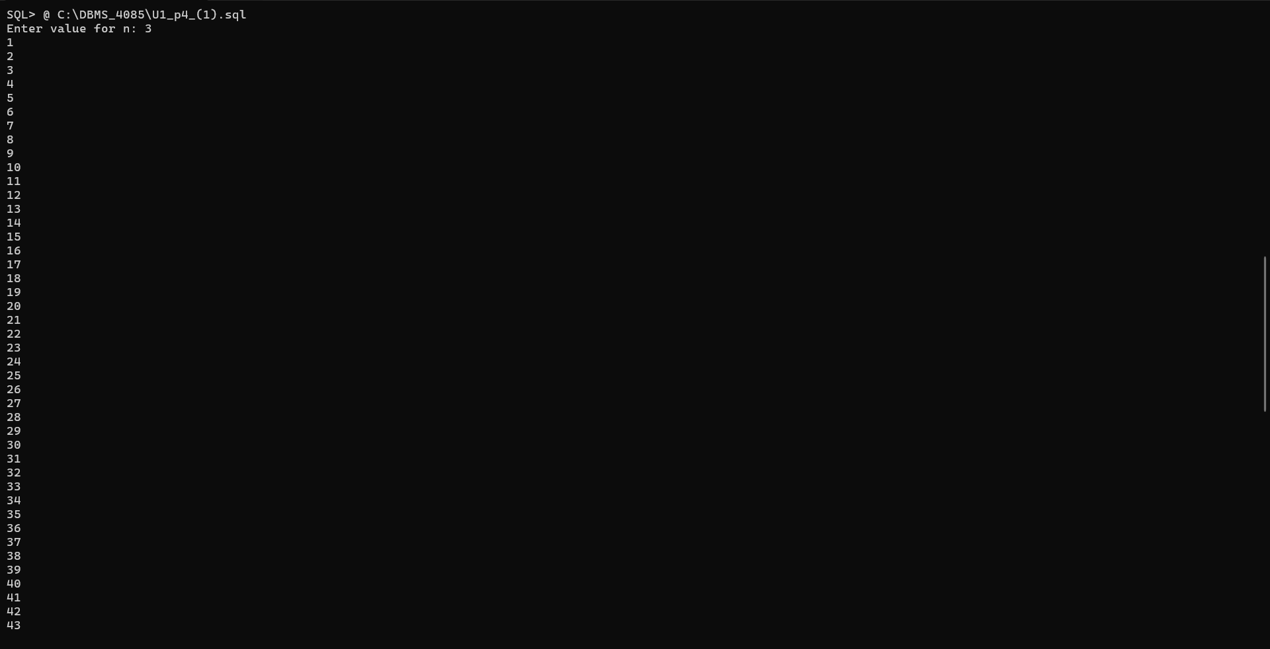



/* Write a program that prints value 1 to 100 number using LOOP Command.*/

set serveroutput on
set feedback off
set verify off

Declare

I number:=1;
Begin

Loop

Dbms_output.put_line(I);
I:=I+1;
Exit when I > 100;

End loop;

End;
/

set serveroutput off
set feedback on
set verify on

Output:
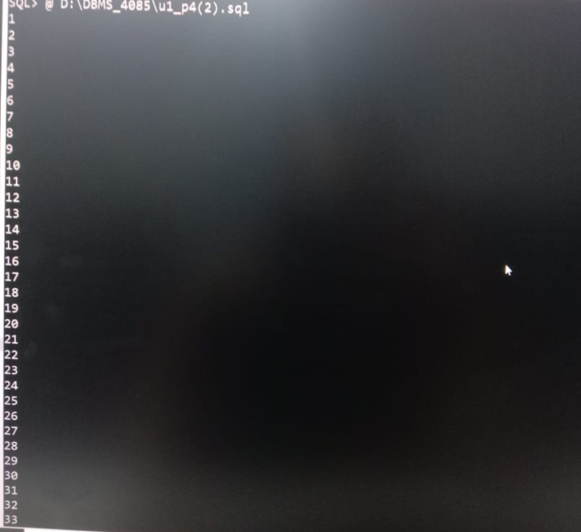


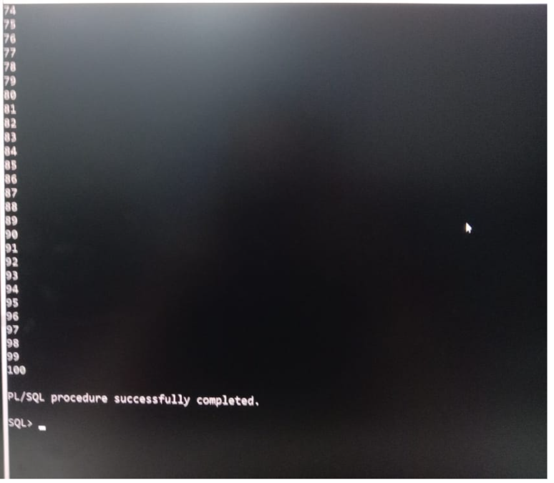

/*Write a program that prints value 1 to 100 number using WHILE LOOP Command*\

set serveroutput on
set feedback off
set verify off

Declare
I number:=1;
Begin

while I <=100

loop

Dbms_output.put_line(I);
I:= I+1;
End loop;

End;
/

set serveroutput off
set feedback on
set verify on

Output:
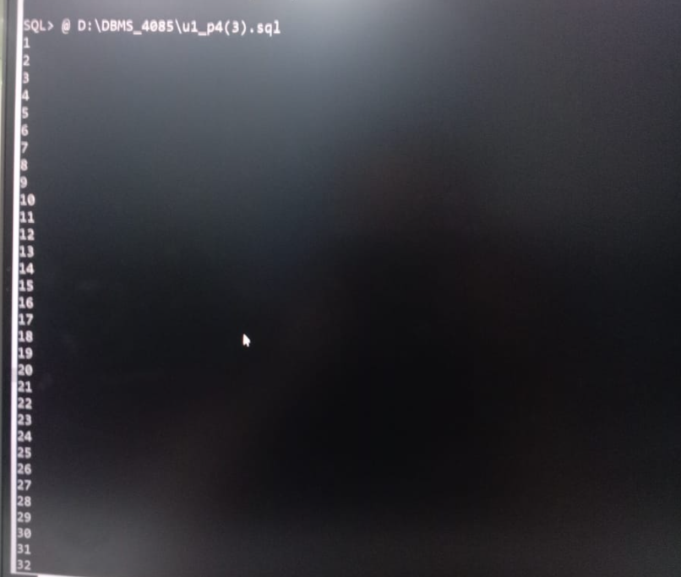



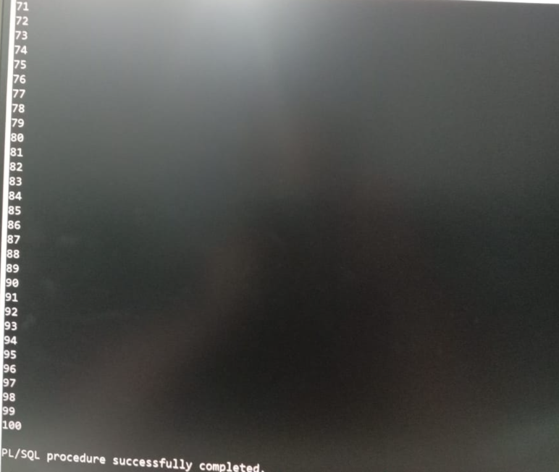

5.Write a PL/SQL block which displays gross salary of employees as per user input EID. (Consider EMP table with EID, EName, Deptno, Deptname Gender, Age, BasicSal) with appropriate data types.) Gross_Salary: BASICSAL + (DA + HRA + Medical) – PF. Rules: HRA = 15% of basic, DA = 50% of basic, Medical = Rs. 500, PF = 10% of basic.

/*Write a PL/SQL block which displays gross salary of employees as per
user input EID. (Consider EMP table with EID, EName, Deptno,
Deptname Gender, Age, BasicSal) with appropriate data types.)
Gross_Salary: BASICSAL + (DA + HRA + Medical) – PF. Rules: HRA =
15% of basic, DA = 50% of basic, Medical = Rs. 500, PF = 10% of basic.*/

set serveroutput on
set feedback off
set verify off

Declare
v_eid number(5);
v_ename varchar(10);
v_deptno number(6);
v_deptname varchar(10);
v_gender varchar(6);
v_basic_sal number(21);
v_age number(3);

v_hra number(10,2);
v_da number(10,2);
v_medical number(10,2);
v_pf number(10,2);
v_totalsal number(10,2);
v_grosssal number(10,2);

Begin
v_eid:= &eid;

select ename, deptno, deptname, gender, age, basic_sal into v_ename, v_deptno, v_deptname, v_gender, v_age,v_basic_sal from emp where eid = v_eid;

v_hra := v_basic_sal * 0.15;
v_da := v_basic_sal * 0.50;
v_medical := 500;
v_pf := v_basic_sal * 0.10;

v_totalsal := v_basic_sal + v_hra + v_da + v_medical;

v_grosssal := v_totalsal- v_pf;

dbms_output.put_line('employee salary details');

dbms_output.put_line('employee id: '|| v_eid);
dbms_output.put_line('employee name:'|| v_ename);
dbms_output.put_line('department no: ' || v_deptno);
dbms_output.put_line('department name: ' || v_deptname);
dbms_output.put_line('gender:'|| v_gender);
dbms_output.put_line('age:' || v_age);

dbms_output.put_line('basic salary: rs. '|| v_basic_sal);
dbms_output.put_line('hra (15%) : rs. ' || v_hra);
dbms_output.put_line('da (50%) : rs. ' || v_da);
dbms_output.put_line('medical : rs. ' || v_medical);
dbms_output.put_line('total salary: rs. ' || v_totalsal);
dbms_output.put_line('pf (10%): rs. ' || v_pf);
dbms_output.put_line('gross salary : rs. ' || v_grosssal);
exception
when no_data_found then

dbms_output.put_line('employee id not found.');

when others then
dbms_output.put_line('error :' || sqlerrm);
end;
/

set serveroutput off
set feedback on
set verify on

Output:

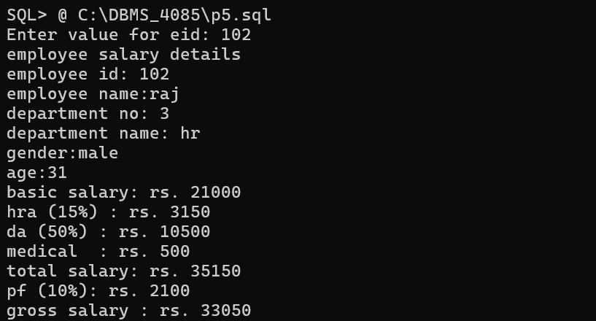

6.Write a PL/SQL block which accepts measurement in feet and displays it in cm, inch and meter.

/*Write a PL/SQL block which accepts measurement in feet and displays it in cm, inch and meter*/

set serveroutput on
set feedback off
set verify off
Declare
feet number(10,2);
cm number(10,2);
inch number(10,2);
meter number(10,2);
Begin
feet:= &feet;
cm:= feet*30.38;
inch:=feet * 12;
meter:=feet * 0.3048;

Dbms_output.put_line('feet :'||feet);
Dbms_output.put_line('centimeter :'||cm);
Dbms_output.put_line('inch :'||inch);
Dbms_output.put_line('meter :'||meter);
End;
/
set serveroutput off
set feedback on
set verify on

Output:

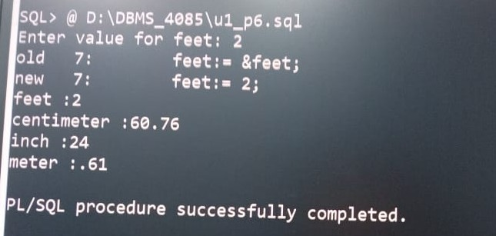

7. Write a PL/SQL block which converts temperature from Celsius to
Fahrenheit.

/*Write a PL/SQL block which converts temperature from Celsius to Fahrenheit.*/

set serveroutput on
set feedback off
set verify off

Declare
choice number(6);
celsius number(6);
fahrenheit number(6);

Begin
choice:=&choice;

if choice =1 then

celsius:=&celsius;
fahrenheit:=(celsius *9/5)+ 32;

Dbms_output.put_line('value of fahrenheit: '||Fahrenheit|| 'F');

elseif choice= 2 then

fahrenheit:= &fahrenheit;
celsius (fahrenheit -32)*5/9;

Dbms_output.put_line('value of celsuis: '||celsius||'c');
else
Dbms_output.put_line('invalid choice...');
end if;
End;
/

set serveroutput off
set feedback on
set verify on

Output:

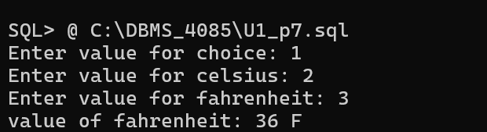

8.Write a PL/SQL block to delete the record of employee for given EID.

/*Write a PL/SQL block to delete the record of employee for given EID*/

set serveroutput on
set feedback off
set verify off

declare
v_eid number;
v_count number;

begin
v_eid := &eid;

select count(*)
into v_count
from emp
where eid = v_eid;

if v_count > 0 then

delete from emp
where eid = v_eid;

commit;

dbms_output.put_line(
'employee record with eid ' || v_eid ||
' has been deleted successfully.'
);

else

dbms_output.put_line(
'employee record with eid ' || v_eid ||
' does not exist.'
);

end if;

end;
/

set serveroutput off
set feedback on
set verify on

Output:

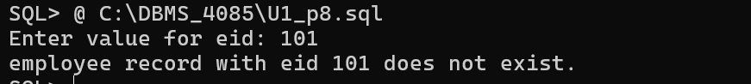

9.Write a PL/SQL block that calculates the simple interest based on given principal amount, rate of interest and number of years.

/*
write a pl/sql block to calculate simple interest based on the given
principal amount, rate of interest, and number of years.
*/

set serveroutput on
set verify off
set feedback off

declare
v_principal number(10,2);
v_rate number(5,2);
v_years number(5,2);
v_interest number(10,2);
v_amount number(10,2);
begin

v_principal := &principal;
v_rate := &rate;
v_years := &years;

v_interest := (v_principal * v_rate * v_years) / 100;

v_amount := v_principal + v_interest;

dbms_output.put_line('simple interest calculation');
dbms_output.put_line('principal amount : rs. ' || v_principal);
dbms_output.put_line('rate of interest : ' || v_rate || ' %');
dbms_output.put_line('number of years : ' || v_years);
dbms_output.put_line('simple interest : rs. ' || v_interest);
dbms_output.put_line('total amount: rs. ' || v_amount);

end;
/
set serveroutput off
set verify on
set feedback on
Output:

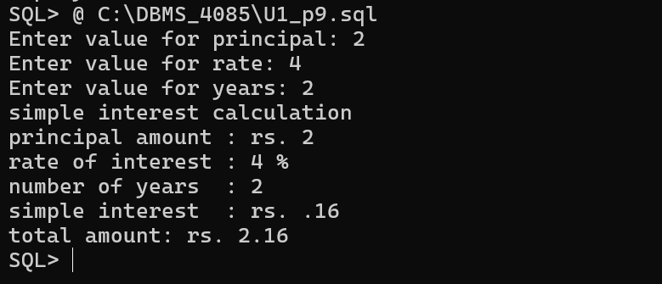

10. Write a PL/SQL block to calculate the square and cube of the given number.

/*write a pl/sql block to calculate the square and cube of the given number.*/

set serveroutput on
set feedback off
set verify off

declare
v_num number;
v_square number;
v_cube number;

begin
v_num := &enter_number;

v_square := v_num * v_num;
v_cube := v_num * v_num * v_num;

dbms_output.put_line('square and cube of a number');

dbms_output.put_line('entered number: '|| v_num);
dbms_output.put_line('square: '|| v_square);
dbms_output.put_line('cube: '|| v_cube);

exception
when others then
dbms_output.put_line('error : '|| sqlerrm);
end;
/

set serveroutput off
set feedback on
set verify on

Output:

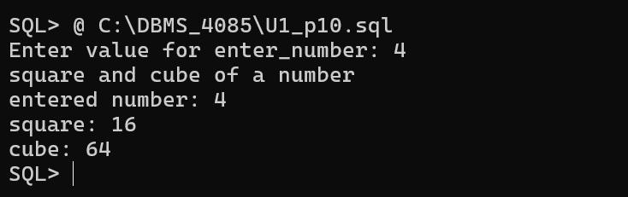

11 . Write a simple procedure that increases by the salary of employees for the given department no. by percentage inputted by the user using IN parameter. Also handle the exception if inputted department number not found.

/*
Write a simple procedure that increases by the salary of employees for
the given department no. by percentage inputted by the user using IN
parameter. Also handle the exception if inputted department number not
found. */

set serveroutput on
set feedback off
set verify off

CREATE OR REPLACE PROCEDURE increase_salary(
p_deptno IN NUMBER,
p_percent IN NUMBER
)
IS
v_count NUMBER;
BEGIN
SELECT COUNT(*)
INTO v_count
FROM employees
WHERE dept_no = p_deptno;

IF v_count = 0 THEN
RAISE_APPLICATION_ERROR(-20001, 'Department not found');
END IF;

UPDATE employees
SET salary = salary + (salary * p_percent / 100)
WHERE dept_no = p_deptno;

DBMS_OUTPUT.PUT_LINE('Salary increased successfully');

EXCEPTION
WHEN OTHERS THEN
DBMS_OUTPUT.PUT_LINE(SQLERRM);
END;
/

set serveroutput off
set feedback on
set verify on

Output:

12. Write a procedure that search whether the given employee number is present or not in the table if present then print name, salary and department number of that employee. (Use both IN and OUT mode variables) and also Write a PL/SQL block to call the SEARCH_EMP procedure.

/*
Write a procedure that search whether the given employee number is
present or not in the table if present then print name, salary and
department number of that employee. (Use both IN and OUT mode
variables) and also Write a PL/SQL block to call the SEARCH_EMP
procedure.*/

SET SERVEROUTPUT ON
SET FEEDBACK OFF
SET VERIFY OFF

CREATE OR REPLACE PROCEDURE SEARCH_EMP(
p_emp_no IN NUMBER,
p_name OUT VARCHAR2,
p_salary OUT NUMBER,
p_dept_no OUT NUMBER
)
IS
BEGIN
SELECT name, salary, dept_no
INTO p_name, p_salary, p_dept_no
FROM employees
WHERE emp_no = p_emp_no;

DBMS_OUTPUT.PUT_LINE('Employee Found');
DBMS_OUTPUT.PUT_LINE('Name : ' || p_name);
DBMS_OUTPUT.PUT_LINE('Salary : ' || p_salary);
DBMS_OUTPUT.PUT_LINE('Department : ' || p_dept_no);

EXCEPTION
WHEN NO_DATA_FOUND THEN
DBMS_OUTPUT.PUT_LINE('Employee not found');
END;
/

SET SERVEROUTPUT OFF
SET FEEDBACK ON
SET VERIFY ON

Output:

13. Write a procedure that accept employee ID and remove records from employee table. Also create a calling program to call procedure.

/*Write a procedure that accept employee ID and remove records from employee table. Also create a calling
program to call procedure.*/

SET SERVEROUTPUT ON
SET FEEDBACK OFF
SET VERIFY OFF

CREATE OR REPLACE PROCEDURE REMOVE_EMPLOYEES(
p_EMPLOYEES_no IN NUMBER
)
IS
BEGIN
DELETE FROM employees
WHERE EMPLOYEES_no = p_EMPLOYEES_no;

IF SQL%ROWCOUNT = 0 THEN
DBMS_OUTPUT.PUT_LINE('Employee not found');
ELSE
DBMS_OUTPUT.PUT_LINE('Employee record deleted successfully');
END IF;

EXCEPTION
WHEN OTHERS THEN
DBMS_OUTPUT.PUT_LINE(SQLERRM);
END;
/

DECLARE
v_EMPLOYEES_no NUMBER := 101;
BEGIN
DELETE_EMPLOYEES(v_EMPLOYEES_no);
END;
/

COMMIT;

SET SERVEROUTPUT OFF
SET FEEDBACK ON
SET VERIFY ON

